**Lesson 1**

**BCA-412 VISUAL PROGRAMMING L T P**

**3 1 0**

**Unit I**

Introduction to Visual Basic: Getting started in Visual Basic – Adding an event procedure – Adding controls – Adding additional event procedures; Data and Operations; Data values and operators – Variables and declaration statements – Assignment statements – Using intrinsic functions.

**Unit II**

Controlling i/o: Interactive user input –Formatted output – Named constants: Selection; Repetition structures; Sub procedures and functions; Structured data: 1-Dimensional arrays – Control arrays.

**Unit III**

Basic graphical user interface concepts; Advanced graphical user interface concepts; Windows common dialogs; The chart and grid controls; The timer, shape, line and toolbar controls; Tree views and list views.

**Unit IV**

Oracle sql: DDL, DML, DCL operations – integrity constraints – string functions – number functions – data arithmetic – transformation functions – grouping and ordering data – subqueries – joins – union, intersect and minus – indexes – clusters – views – sequences – synonym – privileges – grant and revoke permission – locks- pl/sql structure – conditional and unconditional controls – loops – cursors – exceptions, Database programming with VB.

**References:**

1. Gary Bronson, Introduction to programming Using Visual Basic 6, Dreamtech publications, II Edition.

2. Treitch, Visual Basic Oracle 8 Programmer’s Reference, Wrox publication.

3. Deitel & Deitel, Visual Basic 6 How to Program, Pearson Education.

4. Nick Showdon, Oracle Programming with Visual Basic, Sybex publication.

**Lesson 1 : Introduction to Visual Basic**

### 1.1 The concept of computer programming

Programming means designing a set of instructions to instruct the computer to carry out certain jobs that are very much faster than human beings can do. The earliest programming language is called machine language which uses the binary code(comprises 0 and 1) to communicate with the computer. However, the machine language is extremely difficult to learn . Fortunately , scientists have invented some high-level programming languages that are much easier to master. Among the high-level programming languages are Java, [Javascript](https://javascript-tutor.net/index.php/tutorial/), C, C++, c# and Visual Basic.

### 1.2 What is Visual Basic?

Visual Basic is a third-generation event-driven programming language first released by Microsoft in 1991. It evolved from the earlier DOS version called BASIC. **BASIC** means **B**eginners' **A**ll-purpose **S**ymbolic **I**nstruction **C**ode. Since then Microsoft has released many versions of Visual Basic, from Visual Basic 1.0 to the final version Visual Basic 6.0. Visual Basic is a user-friendly programming language designed for beginners, and it enables anyone to develop GUI window applications easily.

In 2002, Microsoft released Visual Basic.NET(VB.NET) to replace Visual Basic 6. Thereafter, Microsoft declared VB6 a legacy programming language in 2008. Fortunately, Microsoft still provides some form of support for VB6. VB.NET is a fully object-oriented programming language implemented in the .NET Framework. It was created to cater for the development of the web as well as mobile applications. However, many developers still favor Visual Basic 6.0 over its successor Visual Basic.NET.

### 1.3 What programs can you create with Visual Basic 6?

In VB 6, you can create any program depending on your objective. For math teachers, you can create mathematical programs such as [Geometric Progression](http://www.vbtutor.net/VB_Sample/GP.htm), [Quadratic Equation Solver](http://www.vbtutor.net/VB_Sample/QESolver.htm), [Simultaneous Equation Solver](https://www.vbtutor.net/VB_Sample/simuleq.htm) ,[Prime Number Tester](https://www.vbtutor.net/VB_Sample/Prime.htm), [Factors Finder](https://www.vbtutor.net/VB_Sample/factors%20Finders.html), [Quadratic Function Graph Plotter](https://www.vbtutor.net/VB_Sample/QGraphplotter.htm) and so on. For science teachers, you can create simulation programs such as [Projectile](https://www.vbtutor.net/VB_Sample/projectile.htm), [Simple Harmonic Motion](https://www.vbtutor.net/VB_Sample/shm.htm), [Star War](https://www.vbtutor.net/VB_Sample/starwar.htm)  etc. If you are in business, you can also create business applications such as [inventory management system](https://www.vbtutor.net/index.php/2013/02/03/inventory-management-system-2/) , [Amortization Calculator](https://www.vbtutor.net/VB_Sample/amortize.htm) , [investments calculator](https://www.vbtutor.net/VB_Sample/Investment.htm), point-of-sale system, payroll system, accounting program and more to help manage your business and increase productivity. For those of you who like games , you can create programs such as [slot machine](https://www.vbtutor.net/VB_Sample/vbslot2.htm), [reversi](https://www.vbtutor.net/VB_Sample/reversi.htm), [tic tac toe](https://www.vbtutor.net/VB_Sample/tictactoe.htm) and more. Besides, you can create multimedia programs such as [Smart Audio Player](https://www.vbtutor.net/VB_Sample/audio.html), [Multimedia Player](https://www.vbtutor.net/VB_Sample/multimp.htm)  and more. Indeed, there is no limit to what program you can create !

### 1.4 The Visual Basic 6 Integrated Development Environment

Before you can write programs in VB 6, you need to install Visual Basic 6 compiler on your computer. You can purchase a copy of [Microsoft Visual Basic 6.0 Learning Edition](https://www.amazon.com/gp/product/B00002SFK8/ref=as_li_qf_sp_asin_tl?ie=UTF8&tag=liewvoonkiong&linkCode=as2&camp=1789&creative=9325&creativeASIN=B00002SFK8) or [Microsoft Visual Basic Professional Edition](https://www.amazon.com/Microsoft-Visual-Basic-6-0-Professional/dp/B00B1T9T0G/ref=pd_sim_sbs_65_4?ie=UTF8&psc=1&refRID=87MRHN3DWNBV1YHCHYTA) from Amazon.com, both are vb6 compilers. Besides, you can also buy it from eBay at [Microsoft Visual Basic 6.0 6 Professional PRO MSDN Library Manual Service Pack](https://www.ebay.com/itm/Microsoft-Visual-Basic-6-0-6-Professional-PRO-MSDN-Library-Manual-Service-Pack-/322782055958?epid=1901581590&hash=item4b274f4e16:g:dPQAAOSw3utY7~52). If you have already installed Microsoft Office in your PC or laptop, you can also use the built-in [Visual Basic Application in Excel](https://excelvbatutor.com/) to start creating Visual Basic programs without having to spend extra cash to buy the VB6 compiler.

You can also install VB6 on Windows 10 but you need to follow certain steps otherwise the installation will fail. First, you need to run setup as administrator. Next, you need to use custom installation. Clear the checkbox for Data Access. If you don't, set up will hang at the end of the installation. Finally, click next and wait for the installation to complete. For complete instructions, please follow this link [Install VB6 on Windows 10](https://www.fortypoundhead.com/showcontent.asp?artid=23993)

After installing the vb6 compiler, the icon will appear on your desktop or in your programs menu. Click on the icon to launch the VB6 compiler. On start up, Visual Basic 6.0  will display the following dialog box as shown in Figure 1.1.

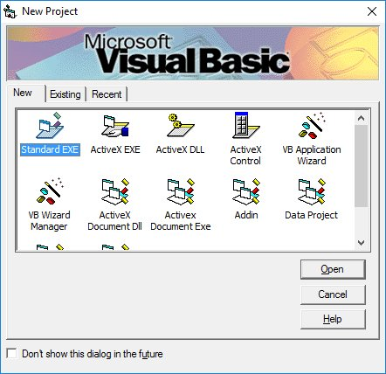

You can choose to either start a new project, open an existing project or select a list of recently opened programs. A project is a collection of files that make up your application. There are various types of applications that we could create, however, we shall concentrate on creating Standard EXE programs (EXE means executable). Before you begin, you must think of an application that preferably have commercial ,educational or recreational value. Next, click on the Standard EXE icon to go into the actual Visual Basic 6 programming environment.

When you start a new Visual Basic 6 Standard EXE project, you will be presented  with the Visual Basic 6 Integrated Development Environment (IDE). The Visual Basic 6 Integrated Programming Environment is shown in Figure 1.2. It consists of the toolbox, the form, the project explorer and the properties window.

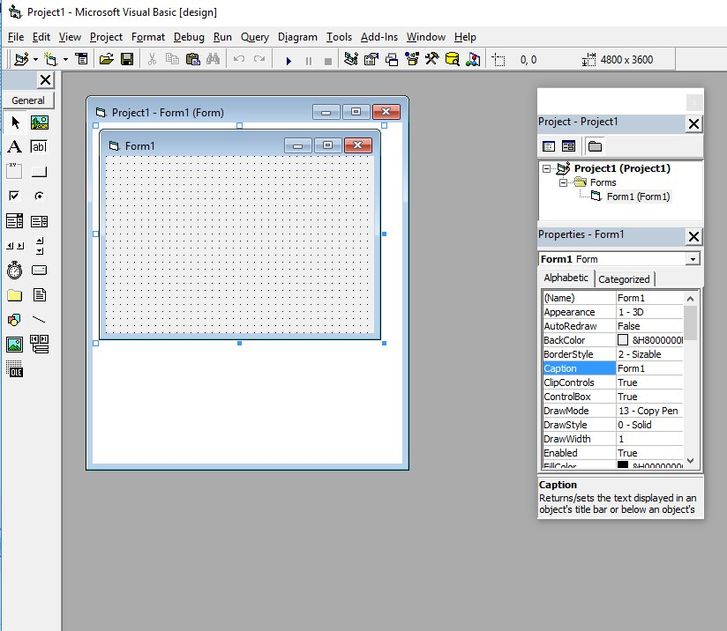

The Form is the primary building block of a Visual Basic 6 application. A Visual Basic 6 application can actually comprise many forms, but we shall focus on developing an application with one form first. We will learn how to develop applications with multiple forms later. Before you proceed to build the application, it is a good practice to save the project first. You can save the project by selecting **Save** Project from the File menu, assign a name to your project and save it in a certain folder.

**Lesson 2:**